NATIONAL DEVELOPMENT COMPANY
Commercial Lot for Lease
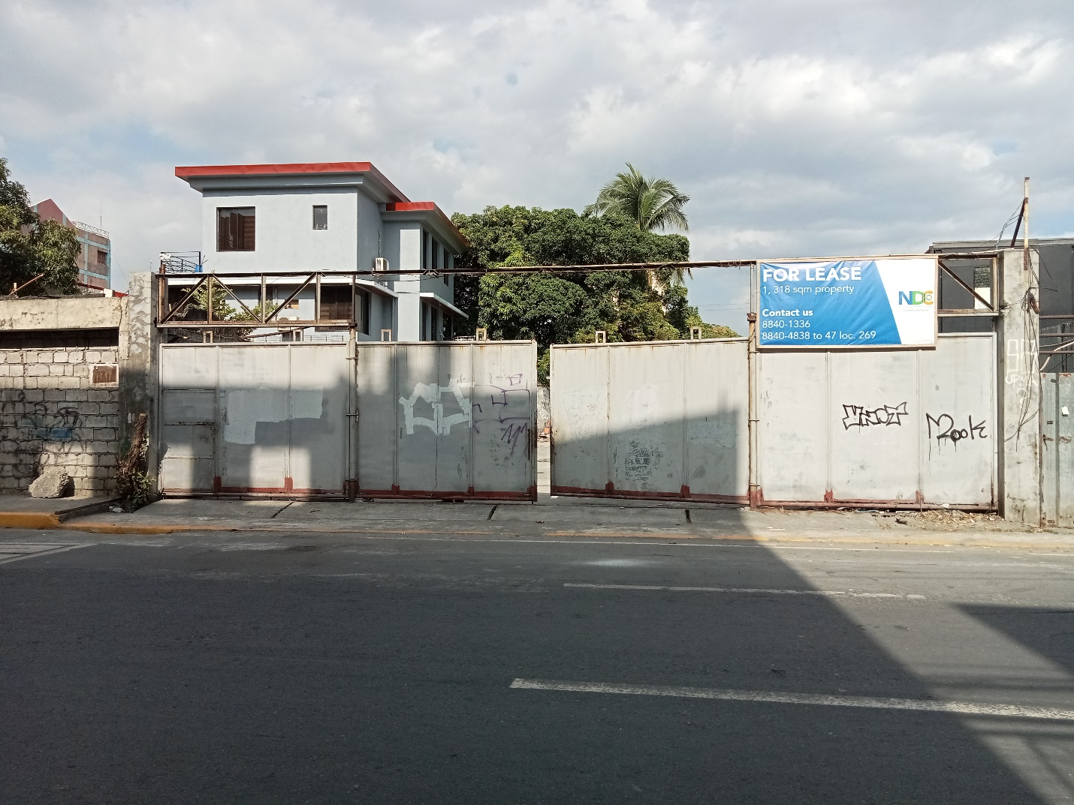
Angel Linao Street, Brgy. 743, Malate, Manila
Area: 1,318 sq.m.
For inquiry, please contact:
+632 8840 1336
+632 8840 4838 to 47 loc. 269

